Νέα θέση εργασίας στην Κορινθία | Sales Assistant Part Time στο νέο κατάστημα Decathlon στο Mare West (Κόρινθος)
Decathlon, one of the largest sporting goods company in the world is moving to Greece to make sport accessible to Greek people.
Are you looking for a new and exciting for job opportunity in the retail industry?
We’re hiring a SALES ASSISTANT (PART TIME) for our next store opening in Corinth (Mare West)

Profile:
Our goal is to make sports accessible for the many, by offering private products signed by decathlon. Technical, reliable products, some of them designed with innovation but always at an outstanding quality-price offer for the customer. Together we would like to write the history of DECATHLON in Greece. Tailor our offer to better match the needs of the sport user like you. For that we would need you to join our ranks and help us in that adventure.

Job Description
- Arranging products
- Communication with customers
- Stock management
- Cashier
- Product delivery

Ideal skills:
- Passion for sports
- Energetic and smiley
- Team player
- Customer centered
- Business level English

Express your interest:
To express your interest in this position, send us your CV: recruitment.korinthos@decathlon.com
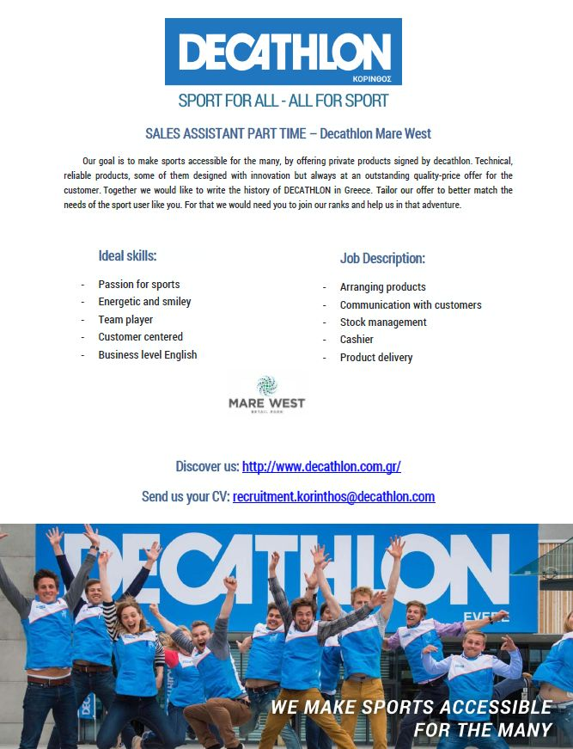
Go take a look at what we do: www.decathlon.com.gr

