

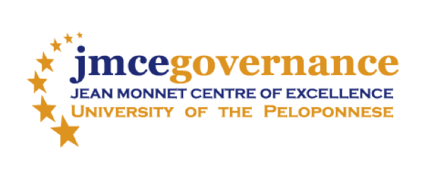

Το [Ευρωπαϊκό Κέντρο Αριστείας Jean Monnet για τη Διακυβέρνηση](https://jmcegovernance.wordpress.com/) του Πανεπιστημίου Πελοποννήσου& το ΠΜΣ στην «[Οργάνωση και Διοίκηση Δημοσίων Υπηρεσιών, Δημοσίων Οργανισμών και Επιχειρήσεων»](http://mapm.uop.gr/) του Τμήματος Οικονομικών Επιστημών

σας προσκαλούν σε εκδήλωση του Κύκλου Ανοικτών Διαλέξεων με θέμα:

**Building Regional Resilience in the EU through**

**Interaction and Innovation**

Κεντρική Ομιλήτρια:

**Professor Heather Fulford,**

Robert Gordon University, U.K.

**Παρασκευή, 15 Δεκεμβρίου 2017**

**ώρα 15.30**

Αμφιθέατρο Σχολής Οικονομίας, Διοίκησης και Πληροφορικής

**Λίγα λόγια για την κεντρική ομιλήτρια:**

 Professor Heather Fulford teaches and researches at Aberdeen Business School, Robert Gordon University (RGU), Aberdeen in Scotland. She has led a number of enterprise and innovation projects designed to bring universities and small businesses closer together for mutual benefit. She is the Director of the Doctoral of Business Administration programme at RGU and the Acting Research Degrees Coordinator for the Business School.

**Λίγα λόγια για το θέμα της ομιλίας:**

Drawing on examples from a number of university-business interaction projects undertaken in Scotland, Professor Fulford will discuss how the resources within a university, including student talent and academic knowledge can be used to foster small business innovation and growth in the EU surrounding region. The benefits derived from such university-business interaction will be explored, and indications given of the challenges encountered and lessons learned along the way. The projects to be discussed took place against a backdrop of political and economic uncertainty as a result of which new perspectives and approaches were needed to ensure the region could become more resilient ad sustainable. The wider implications of the learning from these projects will be considered for other areas of the EU experiencing similar turbulent times.